**Chapter 1**

**BIJAPUR HERITAGE**

Bijapur is a historical city in Karnataka. The city is famous for its ancient monuments, mosques, mausoleums, palaces, fortifications and other structures. Situated at a distance of about 530 km to the northwest of Bangalore, Bijapur attracts scores of tourists who flock to have a glimpse of the historical, cultural and architectural beauty of the city.

Bijapur was renamed as **Vijayapura** in 2014.

**1.1 Aim:**

1. To understand the Transport situation in Bijapur.
2. Gaining in depth knowledge about the culture and the historical monuments in Bijapur.

### **1.2 History of Vijayapura**

Bijapur is an ancient city that was founded in the 10th-11th century by Kalyani Chalukya’s, the then rulers of South India. During that period, it was known as Vijayapura which means the ‘City of Victory.’ Later it came under the rule of the Yadava’s and then the Bahmani Sultanate of Gulbarga. It was the capital of the Adil Shahi kings from 1489 to 1686. The city came under the dominion of Aurangzeb in 1686 and from then the downfall of this city started.

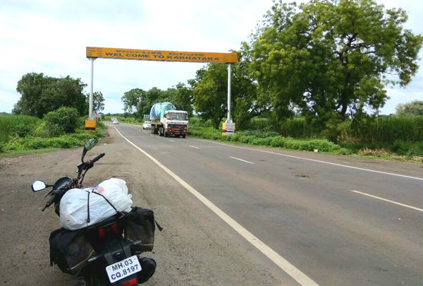 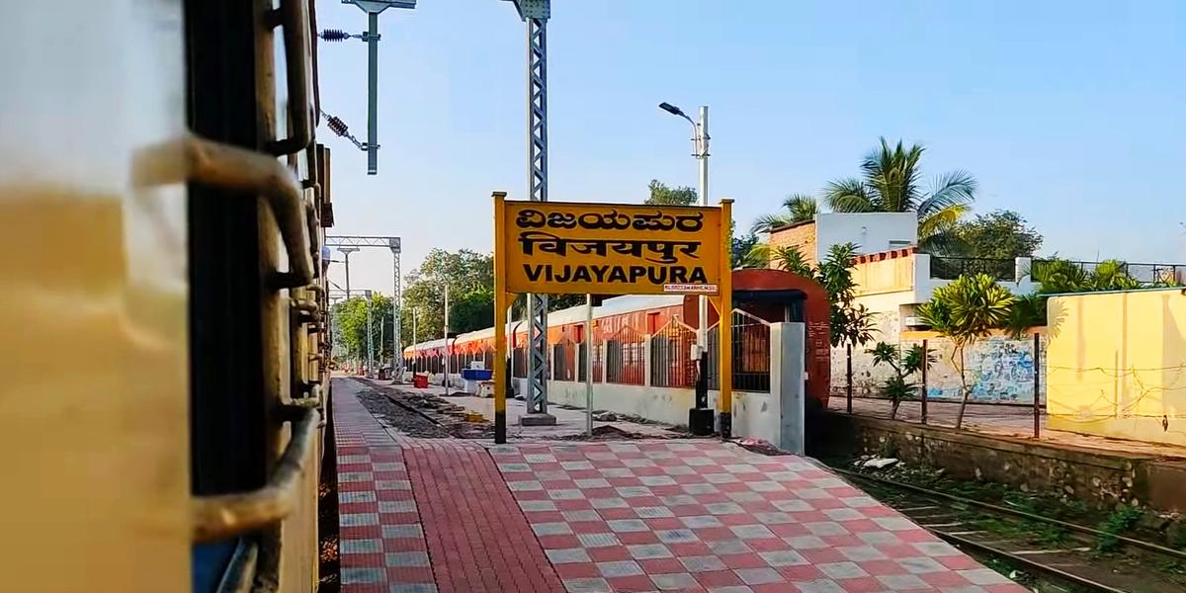

**Fig 1.1: Road-Ways & Rail-Ways**

The Bijapur district is historically, traditionally and legendarily, one of the richest districts in the state. The evidence found here reveals that it was an inhabited place since the Stone Age. The history of this district is divided into four periods, from the Chalukya acquisition of Badami till the Muslim invasion.

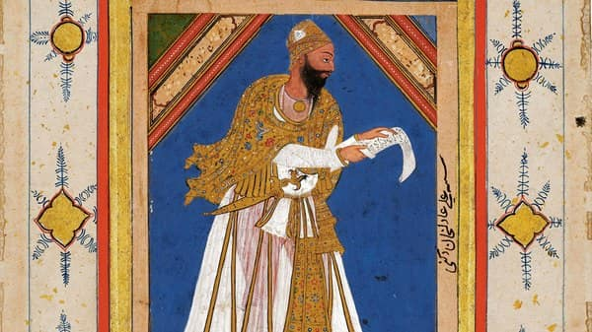**Fig 1.2: Bijapur Sultanate**

In 1347, when the Bahamani dynasty was established, it included southern and eastern parts of Bijapur district. The supremacy of the Bahaman’s may be said to have ceased by 1489. At that time five Shahi Dynasties were born and one of them was “Bijapur”. The Mughal emperor Aurangzeb conquered Bijapur in 1686 and it was under Mughal rule up to 1723. In 1724 the Nizam of Hyderabad established his independence in the Deccan and included Bijapur within his dominions. However, his acquisition on this portion was of brief duration, in 1760 it went it went into the hands of Marathas. In 1817, war broke out between the British and the Marathas. By 1818, the whole of Bijapur was occupied by the British and was included in the territory assigned to the Raja of Satara. In 1848 the territory of Satara was obtained through the failure of heir and the British rule started. Till 1884, the Bijapur district had headquarters at Kaladagi. Bijapur was made headquarters in 1885.

After Independence, the movement for re-organisation of States gained further momentum and on 1 November 1956 a separate "Mysore State" was formed. By the wish of the people, it was renamed as "Karnataka".

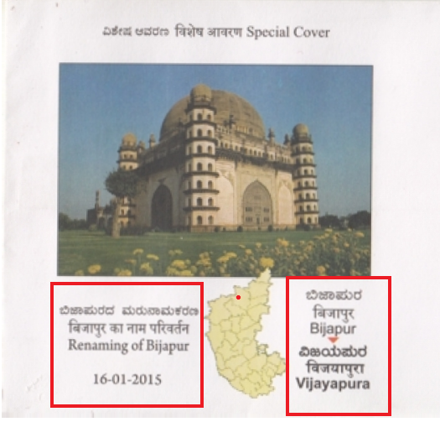

**Fig 1.3: Renaming of Bijapur**

Thus, the district Bijapur along with other Kannada speaking areas became a part of "Karnataka State" on 1 November 1956. Central government had approved the request to rename the city in October 2014 from Bijapur to "Vijayapura" on 1 November 2014

**1.3 Tourism in Vijayapura**

Bijapur has several monuments and structures that are worth visiting. Some of them are:

**i. Gol Gumbaz**

Gol Gumbaz or Gol Gumbadh is a mausoleum of Mohammad Adil Shah who was the sultan of Bijapur. This circular dome is the second-largest one in the world. It took 20 years to build and was completed in the year 1656.One of the unique features of Gol Gumbaz is that the interior of the huge dome is unsupported. The dome has superb acoustic features that ensure even the softest of whispers is clearly heard inside it.

The Gol Gumbaz was planned as a single mammoth structure, and till date remains one of the biggest domes in the world. The foundation of the tomb is rested on the bedrock. The remarkable feature of this gallery is the acoustics, where the slightest whisper is magnified ten times earning it name of the Whispering Gallery.

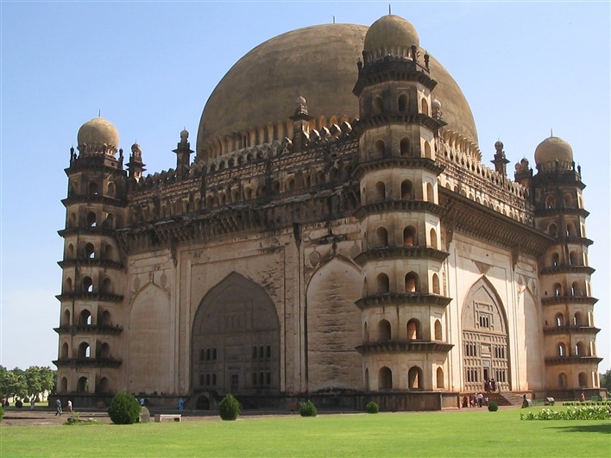**Fig 1.3.11** **Gol Gumbaz**

A mausoleum built for Mohammed Adil Shah, the 7th ruler of the Adil Shahi dynasty. “Gombadh” in Urdu means dome and thus Gol Gumbaz literally translates to the circular dome. Inside the crypt, as you enter on the ground floor is a raised platform at the centre. A decorative frame covers a white slab below which is the actual grave**,** along with his two wives- Taj Jahan Begum, Aroos Bibi, his mistress Rambha, his daughter and grandson.

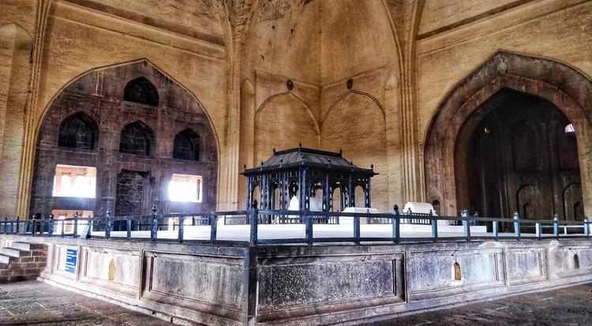**Fig 1.3.12 Tomb of Md Adil Shah**

**Architecture:**

The structure is composed of a cube, 48 m (156 ft) on each side, capped by a [roof](https://en.wikipedia.org/wiki/Roof) 44 m (144 ft) in external diameter. Eight intersecting arches created by two rotated squares that create interlocking [pendentives](https://en.wikipedia.org/wiki/Pendentive) support the dome. At each of the four corners of the cube, is a dome-capped octagonal tower seven stories high with a staircase inside. The upper floor of each tower opens on to a round gallery which surrounds the dome. The dome is one of the largest domes constructed before the modern era. There is a museum within the complex. The museum was established during the British rule in 1892. Its height is 51metre.

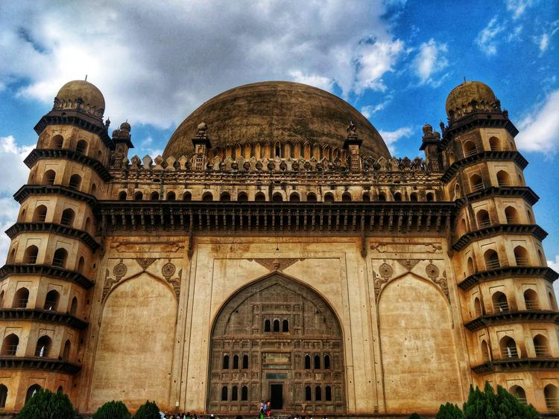

**Fig 1.3.13 Gol Gumbaz with its 4 dome-capped towers**

Another attraction at the Gol Gumbaz is the Whispering Gallery, where even minute sounds can be hear clearly 37 metres away. Gol Gumbaz complex includes a mosque, a Naqqar Khana (a hall for the trumpeters) (now it is used as museum) and the ruins of guest houses. Its vast dome is said to be the Second Largest Dome, unsupported by pillars, in the world, after St. Peter’s in the Vatican City of Rome. It is constructed in such a way that even a pin drop can be heard distinctly from across a space of 38 m, in the Whispering Gallery. The acoustics here are such that any sound made is said to be repeated 10 times over. In the surrounding ornamental gardens is an archaeological museum.

**Visiting Timings:** Morning 10 AM IST to Evening 6 PM IST

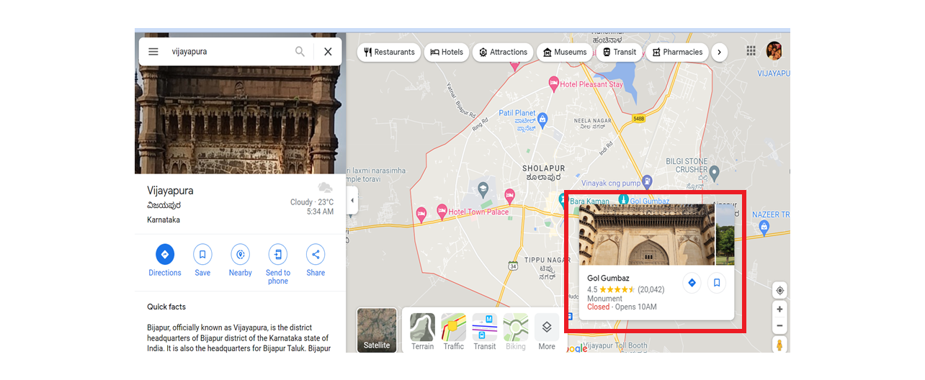**Cost for Entry**: ₹25 (Indians); ₹500 (non-Indians) /1.5 hrs

**Fig1.3.14 Location of Gol Gumbaz**

**ii. Gagan Mahal**

Gagan Mahal is a palace in combination with audience hall which is situated in Bijapur of Karnataka. It is one of the famous tourist attractions of Bijapur. The name of this monument was chosen due to its amazing view of the sky. Gagan Mahal is regarded as a delicate building with small yet stunningly decorated galleries, windows and sophisticated carvings. It features the thoughts of science where the structure of the palace was designed for effective refrigeration, irrespective of any air conditioning system. Gagan Mahal possesses a well-designed pool which act as water drainage system of 16th century establishment. Although several portions of the palace has been damaged due to negligence, it still have certain noteworthy features which are quite pleasant to observe.

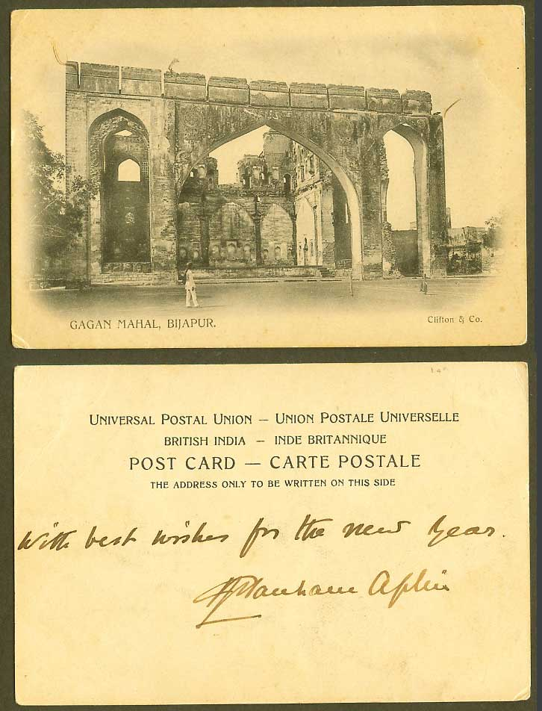

**Fig 1.3.21 Postcard**

Surrounded by fortified walls and a wide moat, the citadel once contained the Durbar Hall, palaces and pleasure gardens of the Adil Shahi Rulers. Unfortunately, many of the buildings are in ruins though some beautiful fragments remain. The best is Gagan Mahal built about 1561 A.D., the building serving the two-fold purpose of a royal residence and Durbar Hall. The main architectural feature of this palace is its great central arch which has a span of 60feet 9 inches. Here was enacted some of the capture of the momentous incidents of history. It was here that, Aurangzeb, after the capture of the city, commanded the unfortunate king, Sikandar Adil Shah to appear before him in silver chains. The building though roofless is a popular spot as it is set in large well landscaped public garden.

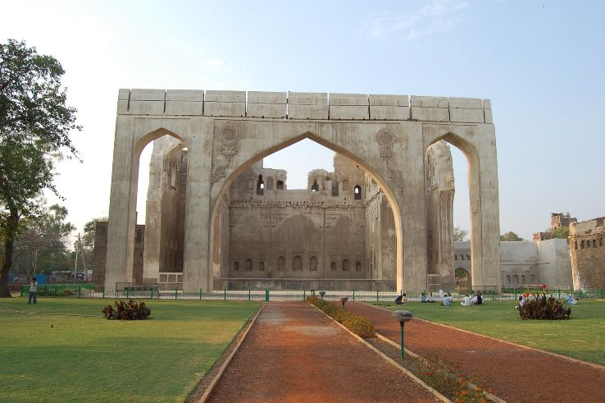**Fig 1.3.22 Gagan Mahal**

Beautiful Indo Islamic method of architecture was used for the construction of Gagan Mahal in Bijapur. The structure was the tallest structure in Bijapur, when it was constructed. Gagan Mahal has two floors. The ground floor of Gagan Mahal was the place for the audience hall or durbar hall. Royal ceremonies and meetings were conducted here during the Adil Shahi regime in Bijapur. The second floor of Gagan Mahal was used as residency for the royal family. The central arch seen on the façade of the Gagan Mahal is one of the tallest arches in the entire Bijapur city and it is surrounded by two arches with size smaller than the middle one. These smaller arches guide people to the upper storey of the Gagan Mahal. However most of the parts of Gagan Mahal including the upper and lower floors are in ruins today. The façade of the building with three major arches is the one and only part of Gagan Mahal which is still standing without much damage. The central arch of the façade has a height of 66 ft (20 meters). According to the historical records, Sikandar Adil Shah, last ruler of Adil Shahi dynasty, surrendered to Aurangzeb in the Gagan Mahal of Bijapur.

**Architecture:**

There are three arches of Gagan Palace where the principal arch is regarded as the tallest and broadest architecture in the whole Bijapur city. It is about 66 feet long and 56 feet height. The platform of the hall is about 80 feet wide where thousands of viewers can accumulate together. The architecture of the palace is splendid and impressive. The three archways of Gagan Mahal is fringed by other archways which lead to narrow stairway of upper floors.

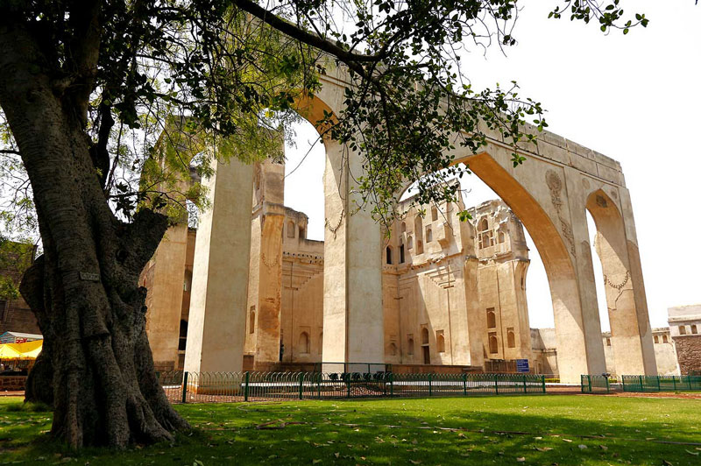

**Fig 1.3.23Side-view of Gagan mahal**

At the ground floor of Gagan Mahal, there is an audience hall a namely 'Durbar Hall'. The key palace of Gagan Mahal is situated in the top floor of the building. The architecture of the hall has significant resemblance with an Opera stadium. The hall is entirely open in one part so that the viewers can gain an unhindered sight of various proceedings from outside of the monument. The building and neighbouring palaces of Gagan Mahal form the royal centre and is enclosed by moat and citadel walls. Presently, Gagan Mahal is a portion of a beautiful open park.

**Visiting Time:** Morning 8 AM IST to Evening 6 PM IST

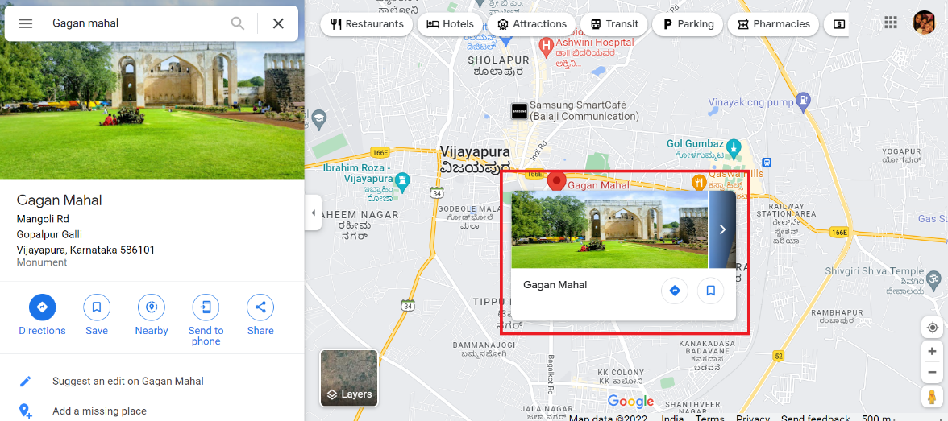

**Fig 1.3.24Location of Gagan Mahal**

**iii. Jumma Masjid**

Jumma Masjid of Bijapur is one of the oldest mosques in India. It was built by Ali Adil Shah I in 1578 to celebrate his victory in the Battle of Talikota in 1565. Spread over an area of about 10810 sq meter is also the largest mosque in the region.Jumma Masjid is known to hold an exquisite copy of the Quran that is written in gold. It can accommodate about 2500 persons offering prayer at one sitting. The Jama-Masjid or [Bijapur](https://en.wikipedia.org/wiki/Bijapur) (also known as Jamiya Masjid or Jumma Masjid) is a [congregational mosque](https://en.wikipedia.org/wiki/Congregational_mosque) in the [Indian state](https://en.wikipedia.org/wiki/States_and_territories_of_India) of [Karnataka](https://en.wikipedia.org/wiki/Karnataka). Initiated by [Ali Adil Shah I](https://en.wikipedia.org/wiki/Ali_Adil_Shah_I) of the [Bijapur Sultanate](https://en.wikipedia.org/wiki/Bijapur_Sultanate) in the 16th century, the mosque was never completed. It is the largest mosque in Bijapur, and has a capacity of 4000 worshippers.

The construction of the Jama Masjid was begun by [Ali Adil Shah I](https://en.wikipedia.org/wiki/Ali_Adil_Shah_I) in the year 1576. The project was financed with money looted from the [Battle of Talikota](https://en.wikipedia.org/wiki/Battle_of_Talikota), in which an alliance of [Deccan Sultanates](https://en.wikipedia.org/wiki/Deccan_Sultanates) had emerged victorious against the [Vijayanagara Empire](https://en.wikipedia.org/wiki/Vijayanagara_Empire" \o "Vijayanagara Empire). Though the majority of the mosque was constructed by 1686, the structure never reached completion.  It nonetheless came to serve as the principal mosque of Bijapur, replacing an older, smaller congregational mosque built by [Ibrahim Adil Shah I](https://en.wikipedia.org/wiki/Ibrahim_Adil_Shah_I).

The building was put by [UNESCO](https://en.wikipedia.org/wiki/UNESCO) on its "tentative list" to become a [World Heritage Site](https://en.wikipedia.org/wiki/World_Heritage_Site) in 2014, with others in the region, under the name [Monuments and Forts of the Deccan Sultanate](https://en.wikipedia.org/wiki/Monuments_and_Forts_of_the_Deccan_Sultanate) (despite there being a number of different sultanates).

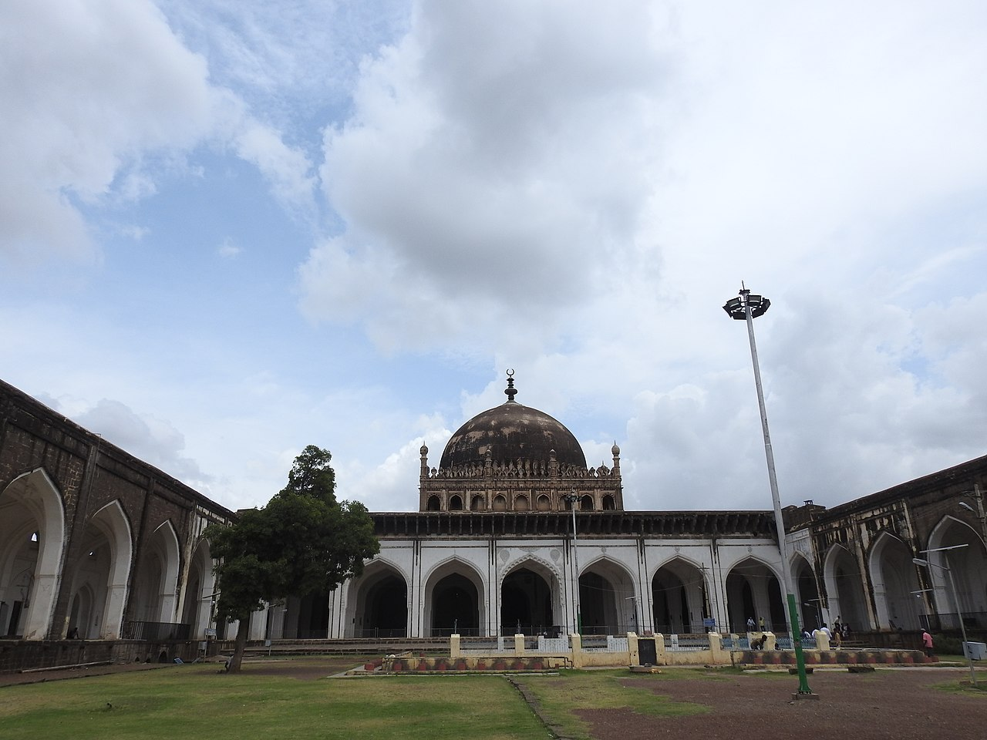**Fig 1.3.31 Jumma Masjid**

Later rulers made some augmentations to the mosque. The addition of murals near the mosque's central [mihrab](https://en.wikipedia.org/wiki/Mihrab) was probably made by [Muhammad Adil Shah](https://en.wikipedia.org/wiki/Mohammed_Adil_Shah,_Sultan_of_Bijapur) [Mughal Emperor](https://en.wikipedia.org/wiki/Mughal_Emperor) [Aurangzeb](https://en.wikipedia.org/wiki/Aurangzeb) added an eastern doorway to the mosque, and made modifications to the prayer hall's flooring.

**Architecture:**

The Jama Masjid is the largest mosque in the city of Bijapur, with a capacity of 4000 worshippers. It is considered one of the finest examples of [Adil Shahi](https://en.wikipedia.org/wiki/Adil_Shahi) architecture. Bianca Alfieri comments that the mosque draws elements from previous [Bahmanid](https://en.wikipedia.org/wiki/Bahmanid_Dynasty" \o "Bahmanid Dynasty) architecture. Jamia Masjid is built on a large area of over one lakh sq ft. Inscriptions from the Quran are carved on the interiors of Jamia Masjid. Jamia mosque campus has a large courtyard, water tank, seating arrangements and mosque building measuring 170 meters by 70 meters.

At the front it represents with nine large arches with five inner arches of 45 compartments. It was built around in the year 1565 without full completion, this masjid is a prayer hall with fine aisles supported on piers with an impressive dome in the frontage with nine inlets. It is also very interesting to see the 2250 inlaid rectangular tiles in the form of prayer rugs in the masjid with the dome in semi-circular shape.

It is said in the year 1636 the mosque was gilded and inscribed with Persian verses and the Mughal emperor Aurangzeb got the mosque extended with eastern gates and verandahs to the east, south and the north. It is also known as Jami masjid or Jumma masjid, it is one of the largest and first constructed mosque of Bijapur built during the rule of Ali Adil Shah who acquired the land after conquering Ramaraja of Vijayanagar.

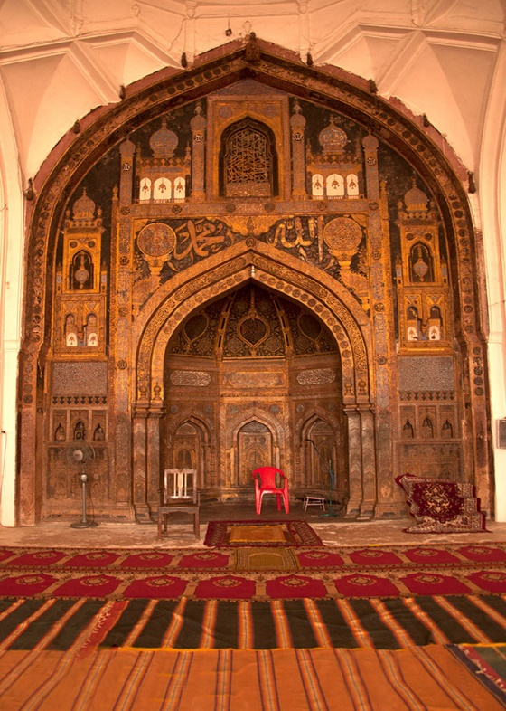

**Fig Fig 1.3.32 Carvings from Quran**

Additionally, [Richard Eaton](https://en.wikipedia.org/wiki/Richard_M._Eaton) notes that the mosque is emblematic of Iranian influence, and does not incorporate local traditions to the extent of later Bijapuri architecture. The design and ornamentation of the mosque are quite simple; [ArchNet](https://en.wikipedia.org/wiki/ArchNet" \o "ArchNet) explains this as a consequence of Ali Adil Shah's [Shiism](https://en.wikipedia.org/wiki/Shiism), since followers of the sect typically preferred less decoration in places of worship.

**Structure:**

The rectangular mosque complex spreads over 5040 m2, and is enclosed by perimeter walls. The main entrance to the complex is the eastern gate. Within the complex is a square sahn (courtyard) of side length 50 m, containing fountains and an ablution reservoir.

Supported by [piers](https://en.wikipedia.org/wiki/Pier_(architecture)), the interior of the prayer hall is divided into five [bays](https://en.wikipedia.org/wiki/Bay_(architecture)), running parallel to the western [qibla](https://en.wikipedia.org/wiki/Qibla) wall. The interior emphasises clean lines over excessive embellishment; only minimal plaster-work is observed. Its floor is divided into 2250 rectangular boxes, resembling a prayer mat, though this was a later addition by Aurangzeb

.

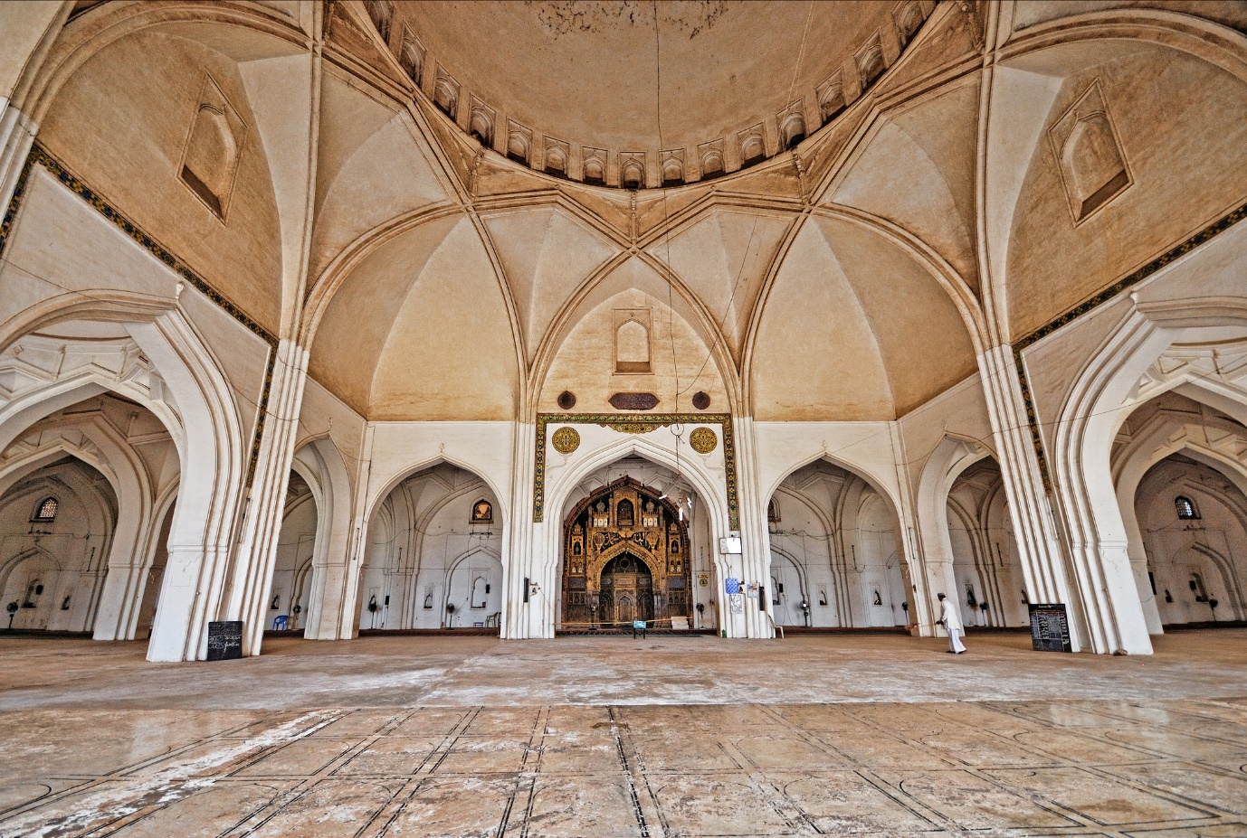

**Fig 1.3.33 Main prayer hall**

The main prayer hall, measuring 70 by 36 m, is situated on the west end of the complex. It is topped with a hemispherical dome, bearing a crescent-moon finial and surrounded by a balustrade at the base.

The generally minimal and austere nature of the interior is interrupted by heavy mural ornamentation surrounding the central mihrab, on the qibla wall. Gilded and decorated in blue, black and gold, the mihrab features varied imagery, and is dominated by [Quranic](https://en.wikipedia.org/wiki/Quranic) epigraphy. The ornamentation is probably a later addition under Muhammad Adil Shah, attested by some [Persian](https://en.wikipedia.org/wiki/Persian_language) inscriptions near the mihrab. Unlike Ali, Muhammad Adil Shah was a [Sunni](https://en.wikipedia.org/wiki/Sunni), and this may be responsible for the stark aesthetic difference between the mosque and its mihrab.  Its luxurious decoration has led Michell and Zebrowski to regard it as one of the finest in the Islamic world; they compare it to the mihrab of the [Mosque–Cathedral in Córdoba](https://en.wikipedia.org/wiki/Mosque%E2%80%93Cathedral_of_C%C3%B3rdoba)

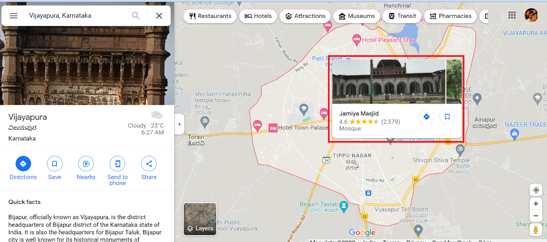**Fig 1.3.33 Location of Jumma Masjid**

**iv. Bijapur Fort**

The Bijapur Fort (Vijapur kote) is located in the [Bijapur city](https://en.wikipedia.org/wiki/Bijapur,_Karnataka) in [Bijapur District](https://en.wikipedia.org/wiki/Bijapur_district,_Karnataka) of the Indian [state](https://en.wikipedia.org/wiki/States_and_territories_of_India) of [Karnataka](https://en.wikipedia.org/wiki/Karnataka). Bijapur fort has a plethora of historical monuments of architectural importance built during the rule of [Adil Shahi](https://en.wikipedia.org/wiki/Adil_Shahi) dynasty.

The [Adil Shahi](https://en.wikipedia.org/wiki/Adil_Shahi) [Sultans](https://en.wikipedia.org/wiki/Sultans) who ruled for nearly 200 years in Bijapur had expended their utmost authority, almost exclusively, on architecture and the allied arts, each Sultan endeavoured to excel his predecessor in the number, size, or splendour of his building projects. As a result, the buildings seen in and around Bijapur Fort and the town have been rightly called as the [Agra](https://en.wikipedia.org/wiki/Agra) of [South India](https://en.wikipedia.org/wiki/South_India).

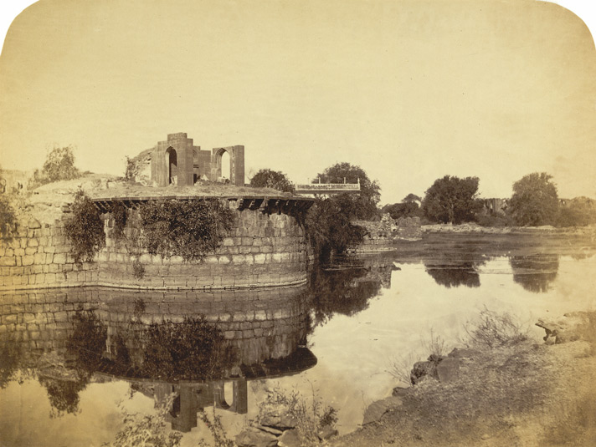

**Fig 1.3.41: Bijapur Fort in Medieval period**

Yusuf built Arkilla fort or Bijapur Fort and Faroukh Mahal whose designers were brought from Persia, Turkey, and Rome. Later, Bahmani kingdom was divided into five small kingdoms and Bijapur was one of them. Seeking the opportunity, Yusuf declared himself the ruler of Bijapur and established Adil Shahi dynasty. Ibrahim Adil Shah succeeded Yusuf Adil Shah in 1510. Ibrahim was a minor when his father died so his mother ruled the kingdom and fought the enemies who wanted to capture Bijapur. Ibrahim built Jami masjid within the fort. Ali Adil Shah I succeeded Ibrahim Adil Shah. He constructed his tomb called Ali Rouza along with Gagan Mahal and Chand Bawdi. Ali also did not have a son so his nephew Ibrahim II succeeded. Since Ibrahim was a minor so the kingdom was protected by Chand Bibi. Ibrahim II was a good ruler who created harmony between Hindus and Muslims and between Shia and Sunni Muslims. That’s the reason the king came to be known as Jagadguru Badshah. The king built many temples and he was also the builder of Gol Gumbaz

**Structure:**

The fort and the citadel within it were completed by Yusuf Adil Shah in 1566. They were built in two concentric circles. The citadel at the centre of the two concentric circles has a circumferential length of 400 metres (1,300 ft). The east–west axis of the fort measures 3 kilometres (1.9 mi). The circumferential length of the fort’s outer wall, which encloses the old city, measures 10 kilometres (6.2 mi). It is strongly fortified with the most massive materials with ninety-six large bastions of various designs. The bastions are decorated with "crenelations and interspersed with machicolations”.

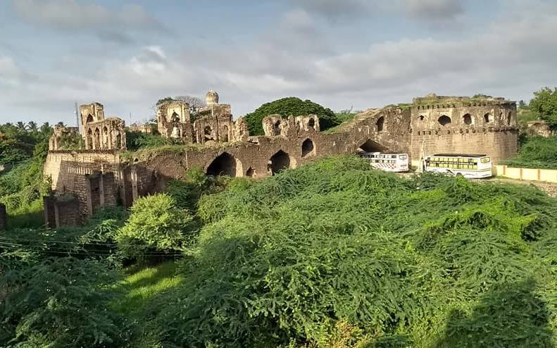

**Fig 1.3.42 Outlook of Bijapur Fort**

In addition, there are ten other [bastions](https://en.wikipedia.org/wiki/Bastions) at the five main gateways (which are arched and decorated entrances) to the fort. It is surrounded by a moat of 30 feet (9.1 m) to 40 feet (12 m) width (assessed depth of 10 feet (3.0 m), but is presently silted up that even obscures its presence and hence its depth cannot be correctly stated). The fort wall has varying height, about 50 feet (15 m) high. The width is about 25 feet (7.6 m); from bastion to bastion runs a battlemented curtained wall about 10 ft (3.0 m) high. The five gateways in the fort are the Makka gate on the west, the Shahapur gate at the north-west corner, the Bahmani gate on the north, the Allahpur gate on the east, and the Fateh gate on the south-east.

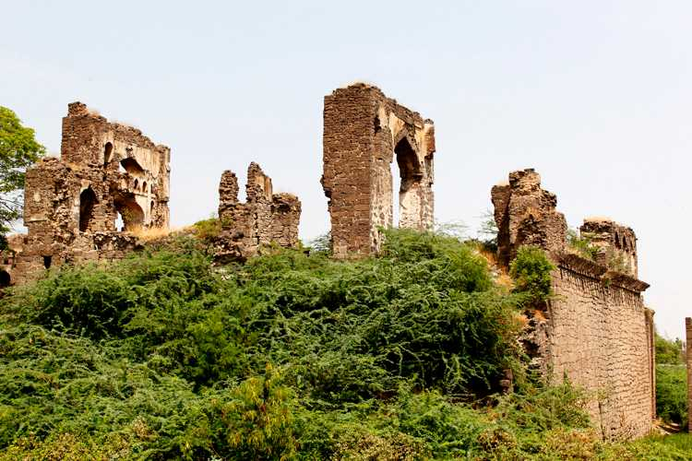

**Fig 1.3.42 Close look**

The palace inside was encompassed by two moats. As also reported, in the mid 16th century, the palace was guarded by 2000 men and the city had a [garrison](https://en.wikipedia.org/wiki/Garrison) of 5000 men headed by Nammouth Chan, an [Italian](https://en.wikipedia.org/wiki/Italians).

**Visiting Time:** Morning 10 AM IST to Evening 6 PM IST.

**Cost for Entry**: ₹15 (Indians); ₹200 (non-Indians)

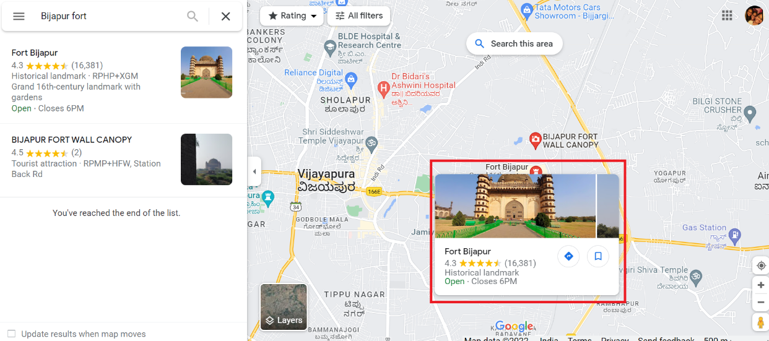

**Fig 1.3.43 Location of Bijapur Fort**

**v. Ibrahim Roza**

On the western outskirts of the city, lies this exquisite group of buildings containing the twin edifices of the sepulchre of Ibrahim Adil Shah and a mosque. The Ibrahim Roza is rated as on one of the most beautifully proportioned Islamic monuments in India and an inspiration for the Taj Mahal. The mosque is also a beautiful edifice with five grand arches, ornamented by carved medallions and hanging stone chains. Built on a high stone terrace, the monuments are framed by a lofty tower, ornamented with four graceful minarets, approached by a path through formal gardens.

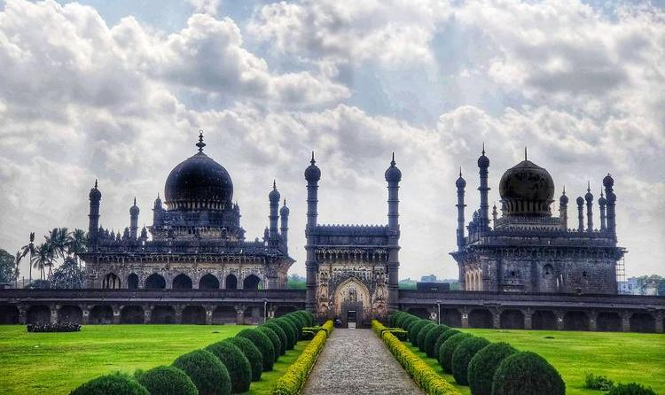 **Fig 1.3.51 Taj Mahal of South India**

Exceptionally conceived and finely decorated, it is one of the supreme achievements of the Adil Shahis. Designed by a Persian architect, Malik Sandal, the tomb and a mosque are set in a walled garden facing each other over an ornamental pond. Graceful minarets mark the corners of each building, surmounted by a dome rising from a lotus petal base. The tomb is supposed to have been an inspiration for the Taj Mahal at Agra.  Sometimes called the ‘Black Taj Mahal’ it is also a tomb garden

**Architecture:**

Ibrahim Roza consists of 2 main structures - A tomb on the left-hand side and a mosque on the right. Both are placed in perfect symmetry on a raised platform facing each other. The tomb was built by Ibrahim Adil Shah II (Bijapur Sultanates 6th ruler) for his queen Taj Sultana for her future burial - This is the reason it has attracted the title of “Taj Mahal of South India”. But such was the will of destiny that Ibrahim died before Taj and his body was buried at the centre of the tomb. His queen Taj was buried right next to him as he would have wished, along with his mother, daughter and other family members. A total of 7 bodies are buried in the main tomb. Designed by a Persian architect under the guidance of Ibrahim, there are calligraphic quotes in Persian language throughout the walls. The doors & windows are very decorative and the carving details in every nook and corner is exemplary. A very serene and peaceful place - highly recommend visiting.

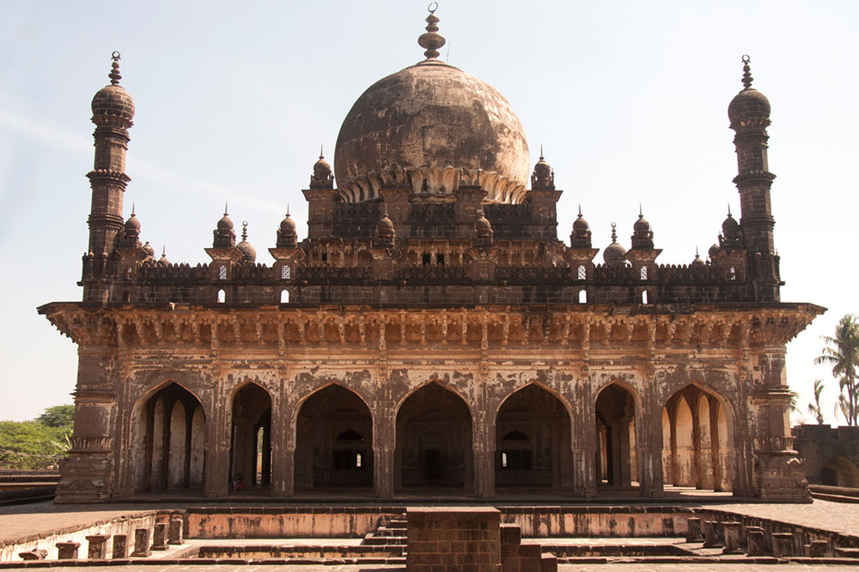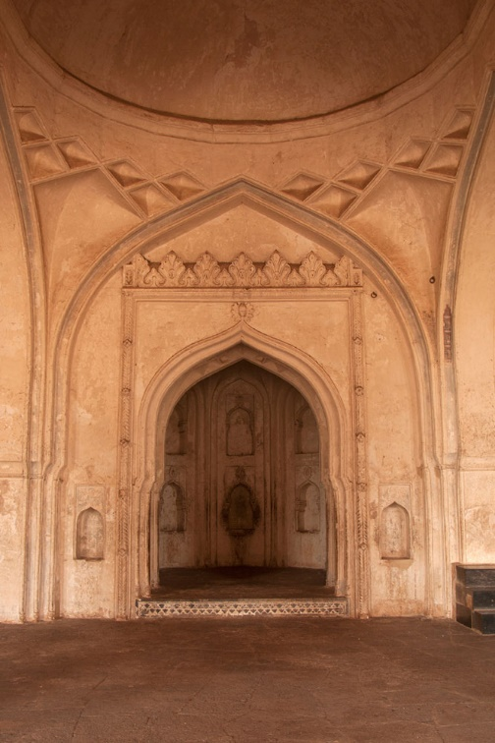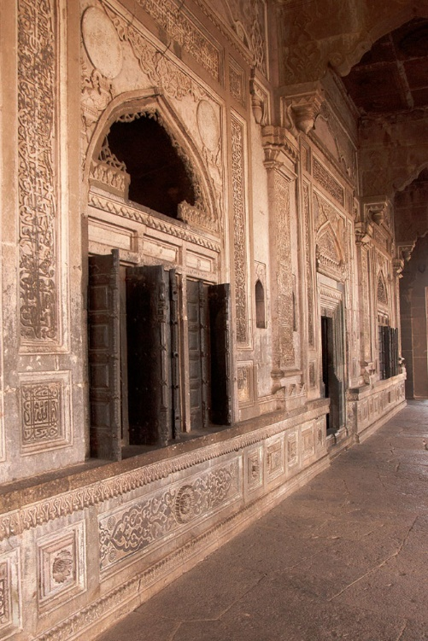

**Fig 1.3.52 Interior of Ibrahim Rauza**

The dome is rising from a lotus petal base, it is said to be a creativeness of the Taj Mahal at Agra with 24 meters. The big fountain and reservoir divide the mosque from the tomb, it is counted one among the beautiful instances of Islamic architecture. This consists of the interconnected buildings, with the faultless domes topped with the crescent moons and surrounded on the four corners with the symmetrical minarets that manages the structural simplicity with intricate stonework with point arches that leads to cool high ceiling chambers and walls richly decorated with sculptures and hangings. The construction was between the 15th to 17th century of the Ibrahim Roza and the mosque built in the walled garden facing the ornamental pond. This was located at about 2 km from Bijapur on the western outskirts of the city. It has significant sculptural decorative work with intricate design works.

**Visiting Time:** Morning 9 AM IST to Evening 5 PM IST. Closed on Fridays.

**Cost for Entry**: ₹5 (Indians); ₹100 (non-Indians)

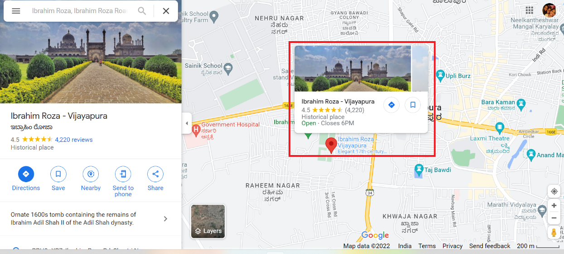

**Fig 1.3.53 Location of Ibrahim Rauza**

**Chapter 2**

**Culture and Heritage of Vijayapura**

### **2.1 LifeStyle**

Bijapur being a tribal territory has the largest number of tribes associated in the country. Bijapur in fact has the oldest and the densest population of tribe in the country, almost untouched for many years now. It is the rarest of conserve culture of the primitive man. The tribal people have their own rules and regulations with women wearing attire which is very different and colourful and jewellery made of beads and metals. The tribes in Bijapur are known for their unique culture and traditional living style. They live in their own world with trust worthy and honest smiling faces. Each tribe has their own dialect and differs from each other the way they dress, their language, life style, celebration and ritual, etc. Folk songs like Mariro, Sona, Dhankul, Chait Parab, Kotni and Jhaliana are very famous.

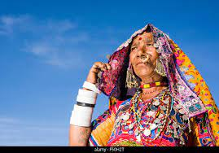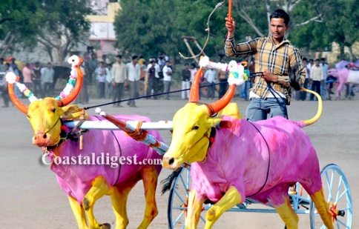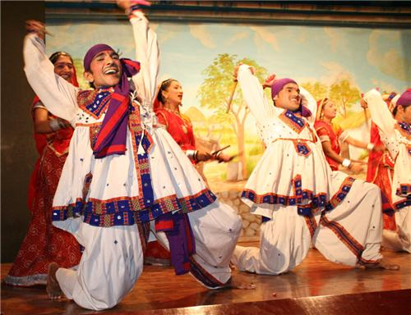All of them worship God Bhairam dev etc. Festivals amongst the tribe are celebrated almost all throughout the year with Faith and joy. However, the tribes are becoming economically weak due to deforestation as lot many of them are dependent on trees. With the extinction of natural forest, it is becoming very difficult for them gradually. Bijapur Festivals preserve the rich tradition and culture of the land. A large number of tribes live amongst them and avoid mixing with local people and always trust each other. They live in complete harmony and worship the trees to protect the forest.Modern society has a lot to learn from them especially the ways to conserve the environment. Bijapur Music Festival is one of the big festivals in Bijapur that is organised by the Government of Karnataka every year. A number of talented artists and musicians can be witnessed in the event for the entertainment, attracting a large number of people to his festival.

**Fig 2.1 Traditions in Bijapur**

**2.2 Inhabitants & Employement**

Gonds Tribe

The Gonds recognized as Koytorias/Kotoriya tribe mainly predominates the forest of Bijapur. The Gonds are uniquely known in India due to their Ghotul system of marriage. Lingo, the supreme deity created the first Ghotul.

## Halbaas Tribe

They are mainly farmers and are not only found in Bastar but they are spread in Madhya Pradesh, Odisha and Maharashtra. The origin of the word Halba is from the word Hal meaning plough and thus known as Halba.

## Dolra Tribe

The people of this tribe are mainly found in the areas of Bhopalpatnam of Bijapur. Dorla community has affinity with cows and pays much respect to deity Bheema Dev.

Weekly haats are held in every village wherein small to big stuffs are sold by the tribes in order to earn a living. The local people come to the haat to enjoy and spend some time buying and having fun. One can even try the local snacks that are sold. Exclusive items like local liquor made from dried mahua flower, rice bear/landa, salphi are the items mostly found here in plenty. They bring thei hand made craft to the haats for better prices. Cock fight is a regular scene to watch here.

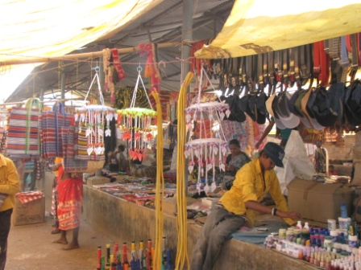

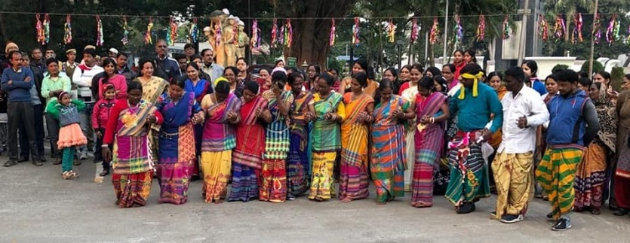

**Fig 2.2 Local Activities in Bijapur**

**Chapter 3**

**Specialization of Vijayapura**

Ilkal saree weaving is found mainly in and around the villages of Kolhar, Ilkal, Kamatgi and Nidagundi located at the Bijapur district of Karnataka. As mentioned above, the specialty of these sarees lies in the pallu, which is usually woven in red and white. The sarees, on the other hand, feature vivid colors such as dark indigo, purple, red and green with their traditional styles of pallus. The pallu and the body are joined using a technique called kondi.

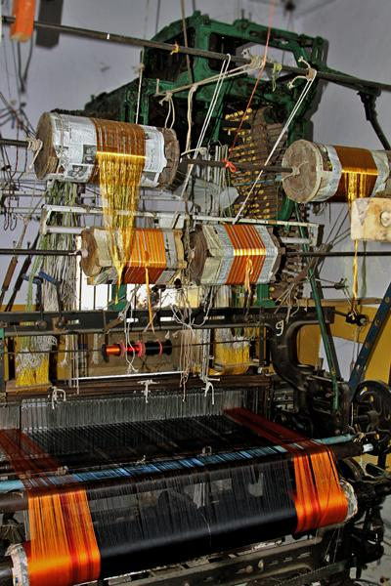

**Fig 3.1Making of Ilkal saree**

If one happens to peep around in this place, almost all house are engaged in weaving these sarees, their is no discrimination done, both men and woven are engaged in weaving to make their livelihood. Major centres of weaving is from villages of Ilkal, Kolhar, Kamatgi and Nidagundi at the Bijapur district and many of them have their own loom at home

**Location**

Original Name: Vijayapura

Geographical Location: Bangalore Rural, Karnataka, India, Asia

Geographical Co-ordinates: 13° 17' 44.098'' North, and 77° 48' 2.7288'' East.

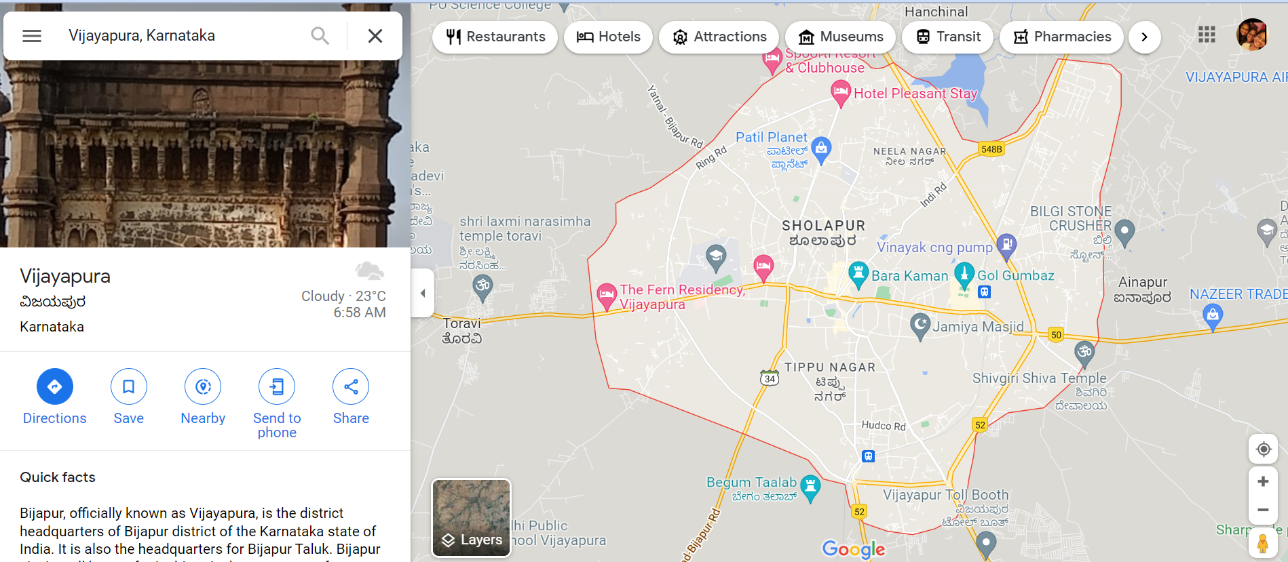

**Fig 6: Map**

REFERNCES

1. <https://www.karnataka.com/bijapur/about-bijapur/>
2. <https://www.incredibleindia.org/content/incredibleindia/en/destinations/vijapura-bijapur.html>
3. <https://www.yatra.com/india-tourism/bijapur-travel-guide>
4. <https://www.tripoto.com/karnataka/trips/revisiting-history-bijapur-vijayapura-the-city-of-victory-5e6f11c1915e6>
5. https://en.wikipedia.org/wiki/Bijapur
6. From native people.

**Team Members**

|  |  |
| --- | --- |
| USN | NAME |
| 2KE21CS402 | Iramma Nagaraj Hegadi |
| 2KE21CS401 | Bhagya Kammar |
| 2KE21CS400 | Ashwini Maruti Rawal |
| 2KE21CS403 | Kanchan S Tripathi |
| 2KE20CS116 | Ch. Sheeba |
| 2KE20CS117 | Bommaji Leuitisha |
| 2KE20CS063 | Radha Kalasad |
| 2KE20CS079 | Sandhya Devendra Naik |
| 2KE21CS405 | Nagaraj Sadanand Raykar |
| 2KE20CS112 | Sadiqahmed M Nadaf |
| 2KE21CS404 | Munthar Misrikoti |